Lab Instructions: Network Traffic & Delay Analysis with Wireshark
Part 1: Setup and Installation
- Download and Install: Download Wireshark from the official website. Wireshark is the industry-standard tool for network traffic analysis.
- Download the Trace file from the course Canvas page.
- Launch: Open Wireshark. You will see a list of networks available for capture.
⚠️ WARNING: Do not capture live traffic on the university network (LaTech)! We will strictly use the provided trace file for this assignment.
- Load the Data: Open the provided Lab1.pcap file. You will see approximately 12,000 packets load into the main window.
Part 2: Understanding the Interface
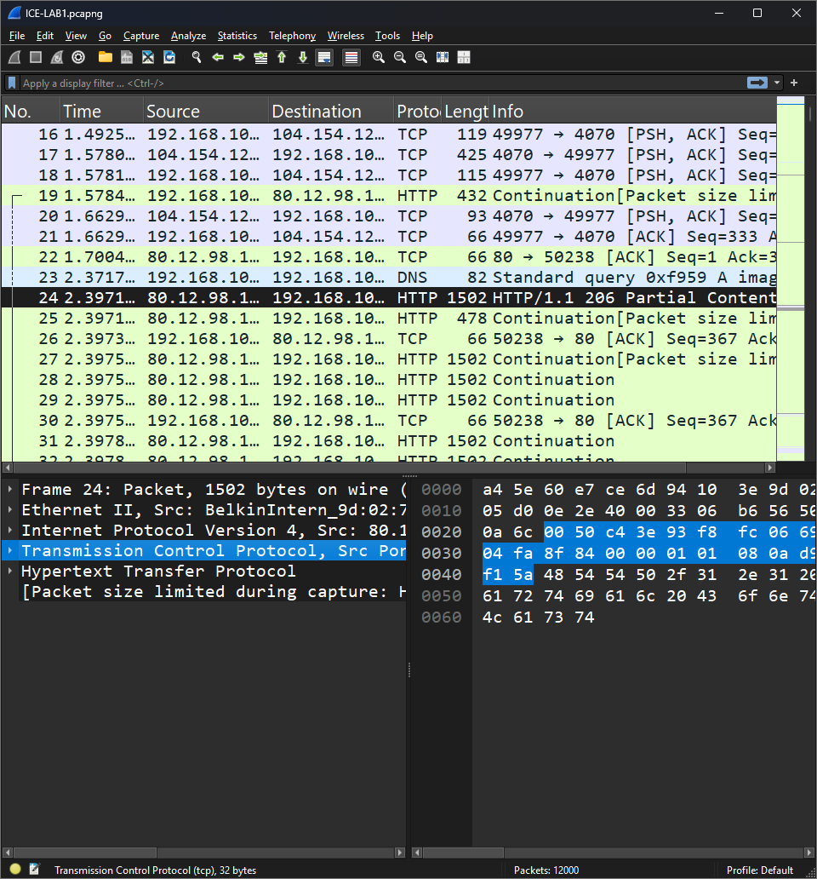
Wireshark is divided into three main default panes. Take a moment to familiarize yourself with them:
- Packet List (Top Pane): Each row represents a single captured packet. Columns display the Packet Number (Serial), Relative Time, Source/Destination IPs, Protocol, and Length.
- Packet Details (Bottom-Left Pane): This shows the protocol stack (encapsulation) for the selected packet. Select a HTTP packet. You can expand each layer to see details:
  - Frame: Link Layer (Ethernet/MAC)
  - Internet Protocol: Network Layer (IP addressing)
  - Transmission Control Protocol: Transport Layer (Ports/Seq Numbers)
  - Hypertext Transfer Protocol: Application Layer (Data)
- Packet Bytes (Bottom-Right Pane): Displays the raw hexadecimal data. Selecting a protocol in the Packet Details Pane will highlight the associated bytes in the Packet Bytes Pane.
  - Tip: You can view a visual structure instead of raw bytes by going to Edit > Preferences > Layout and selecting "Packet Diagram" for pane 3.
Part 3: Optional Analysis
Before digging into delays, get an overview of the traffic:
- Identify the Client: In this specific trace file, the client device IP is 192.168.10.108.
- View Conversations: Go to Statistics > Conversations. This window summarizes traffic volume between endpoints at different layers:
  - Ethernet: Link layer (MAC addresses).
  - IPv4/IPv6: Network layer (IPv4 uses 32-bit addresses; IPv6 uses 128-bit addresses).
  - TCP/UDP: Transport layer.
- Basic Filtering: You can filter for specific protocols. Type http in the display filter bar at the top (it turns green if the syntax is correct) and hit Enter. This filters the view to show only HTTP web traffic.

Part 4: Lab Task – C onfiguring for Delay Analysis
To find network lag, we need to customize our view to show the time difference between packets.
- Adjust Cache Settings: To ensure all packets are sorted correctly, go to Edit > Preferences > Appearance and ensure "Maximum number of cached rows" is set to at least 20,000.
- Add the Delta Column:
  - Select any TCP packet in the top pane.
  - In the Packet Details pane, expand the Transmission Control Protocol arrow.
  - Expand Timestamps.
  - Right-click on Time since previous frame in this TCP stream.
  - Select Apply as Column.
- Rename the Column:
  - Right-click the header of the new column you just created.
  - Select Edit Column.
  - Change the title to "TCP Delta".
Part 5: Investigating Server-Side Delays
We are specifically looking for delays originating from the server.
- Identify the Server: Locate packets involving the server IP 184.85.75.86.
- Isolate the Conversation: Right-click on any packet involving this server IP and select Conversation Filter > TCP. This selects packets from this conversation.
- Analyze the Handshake:
  - Click the "No." (Serial) header to sort by packet number.
  - Find the first three packets. These represent the 3-Way Handshake ([SYN], [SYN, ACK], [ACK]).
  - Observe the sequence numbers and flags in the Packet Details pane to understand how the connection started.
- Find the Lag:
  - Click the new TCP Delta column header to sort the packets by time.
  - Look for the highest values. These represent the longest pauses between packets in the stream.
  - Note: Do not worry about why the delay happened for now; your goal is simply to identify where it happened.
Part 6: Submission Requirements
- Screenshot: Take a clear screenshot of the packet list showing the packet with the high "TCP Delta" value.
- Write-up: Briefly describe the process you followed to configure Wireshark and find the high-delay packet.
- Submit: Upload your document to Canvas.

